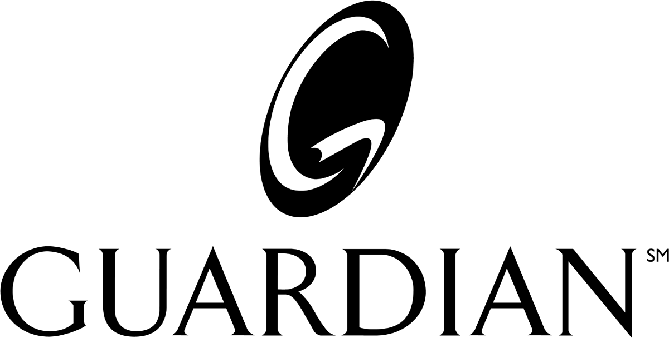

GUARDIAN SERVICE CONTACT POINTS

GUARDIAN CUSTOMER RESPONSE UNIT - (CRU)
For all questions that you or your client’s plan administrator may have regarding the administration, billing, or eligibility of the Guardian plan. The CRU offers “one stop” professional and timely service.

E-Mail – crumro@glic.com
Phone – (800)-627-4200 – Guardian customer service
(866)-866-4542 – First Commonwealth customer service

FCW CUSTOMER RESPONSE UNIT – 1-866-866-4542

ADMINISTRATIVE CENTER
Mail or Fax Enrollment forms, changes, additions, or terminations to:
Guardian
Mid-Western Regional Office
P.O. Box 8012
Appleton, WI 54912-8012
FAX: (920) 749-5250
Guardian Anytime – On line administration support:

Phone – (877) 500-2386 – Registration Issues
(800) 627-4200– Navigational Issues

(

Flex Plan Administrative Center – Section 125 plan administration and claim questions.
Phone – (866) 359-4542

Employee Claim-Related Questions/Appeals:
Dental Claims
Guardian
Group Dental Claims
P.O. Box 2459
Spokane, WA 99210 2459
Employee / Dentist (800) 541-7846 Agents / Plan Admin (800) 627-4200

Short Term Disability Claims Guardian
Group Disability Claims
P.O. Box 26160
Lehigh Valley, PA 18002-6160
(800) 268-2525 - STD
Long Term Disability Claims
Guardian
Group Disability Claims
P.O. Box 26025
Lehigh Valley, PA 18002-6025
(800) 538-4583 – LTD

Life Claims
Guardian
Group Life Claims
P.O. Box 26035
Lehigh Valley, PA 18002
(800) 525-4542

DBL Claims
Guardian
116 John Street
New York, NY 10038
Phone (800) 624-5202
Fax (212) 608-6473

Vision Claims
VSP
Phone (800) 877-7195
www.vsp.com
DAVIS VISION
Phone (877) 393-7363

MDG
Phone (800) 273-3330 (California)
(888) 618-2016 (Texas)

First Commonwealth
Phone (866) 302-4542 (PPO)
(866) 494-4542 (Prepaid)
Medical Claims
Guardian Group Medical Claims
P.O. Box 8007
Appleton, WI 54912
Employee/Provider (800) 873-4542
Agents / Plan Admin (800) 627-4200

